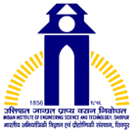 | ROBO-YANTRIK  APRIL 2025-SEPTEMBER 2025

The Newsletter of
SCHOOL OF MECHATRONICS AND ROBOTICS
IIEST, Shibpur

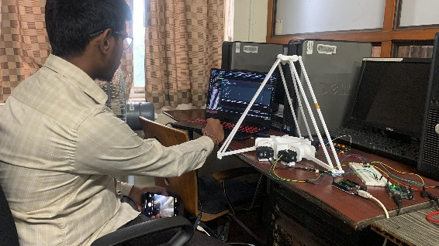  The Delta parallel robot | 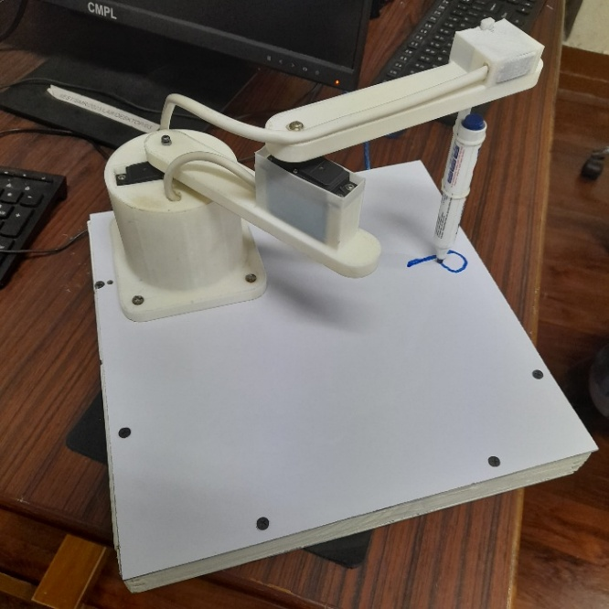  SCARA based handwriting robot
Highlights

Co-innovation Centre: Grant Allotment by IHFC-IIT Delhi
Institute Engineers’ day Celebration
Lab development: Acquisition of IoT based Healthcare setup
Consultancy with Science City for the development of animatronic mechanisms

Participation in faculty development programme
Project Presentation and Allotment of Grant by IHFC-IIT Delhi as a part of Co-innovation Centre Activities
The I-Hub Foundation for Cobotics (IHFC-IIT Delhi) as per its signed MoU evaluated multiple project proposals submitted by faculty and startups through the Co-innovation Centre.  The project presentations were organised on July 19, 2025, with the proposals evaluated by a panel headed by Prof. Subir Kumar Saha, Director IHFC,  Three PIs were granted projected, with Dr. Tanmay Pal, Head SMR receiving a research grant of INR 10 Lakhs.  IHFC also decided to fund the student Mr. Harshit Kashera (final year EE student from IIEST) as a part of its READY program for his articulated robotic arm project. Further Dr. Joydeep Bhowmick and Prof. Chirasree RoyChowdhury have been granted funds of INR 25 lakhs and INR 20 lakhs by the evaluating team to help them commercialise their products. | 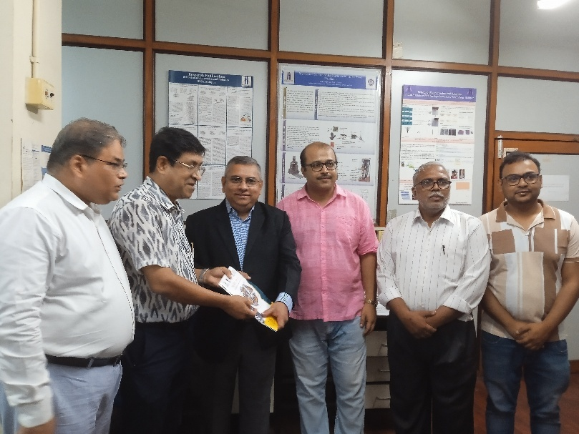
INSTITUTE ENGINEERS DAY CELEBRATION IN ASSOCIATION WITH EE
The School of Mechatronics and Robotics co-organised the Engineer’s day celebration along with the department of Electrical Engineering on the 15th of September 2025. The event comprised of a garlanding ceremony of the statue of M. Visveswaraya followed by two plenary talks. The garlanding session was graced by the Director Prof VMSR Murthy and the Registrar CA Biswajit Bhattacharya. The main event was graced by the Dean Academic, Prof. Arindam Biswas, Dean R&C, Prof. Pratik Dutta and two invited guests of Honour, Prof. Karabi Biswas from the Department of Electrical Engineering, IIT Kharagpur and Mr. Sandip Pal, Vice-President, Operations at CESC. The whole event was coordinated by Head SMR, Dr. Tanmay Pal and Head EE, Prof. Aparajita Sengupta, who spoke briefly about the occasion and its significance in the context of the presentacademic scenario.  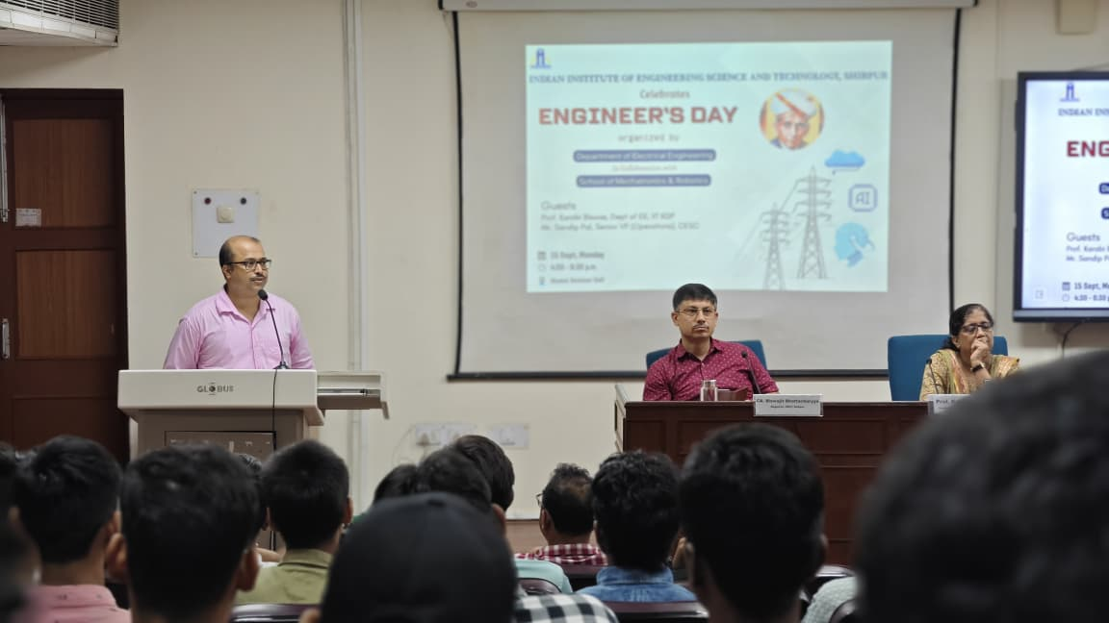 | 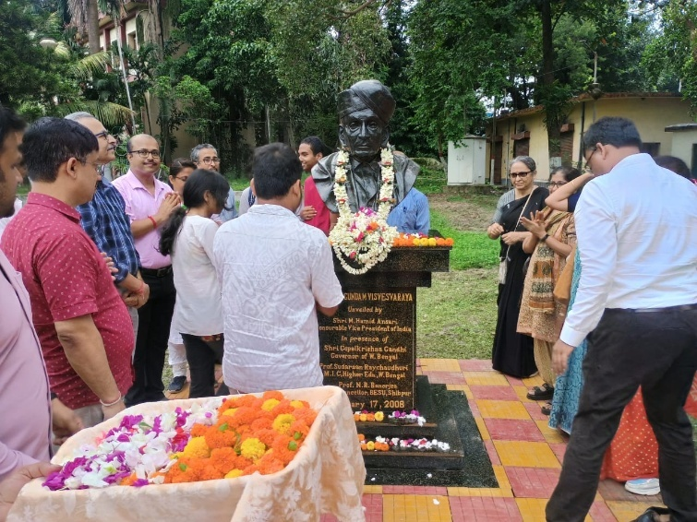  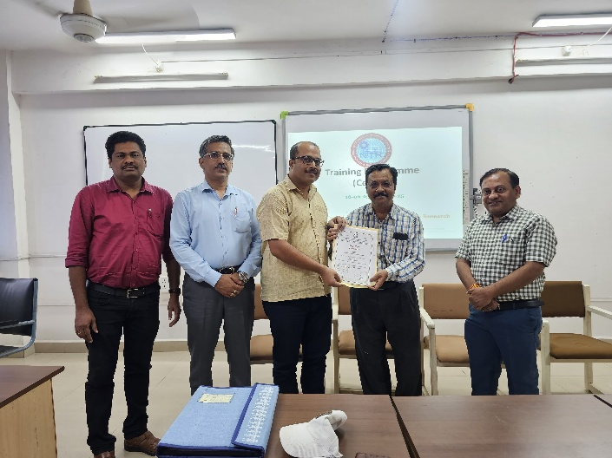  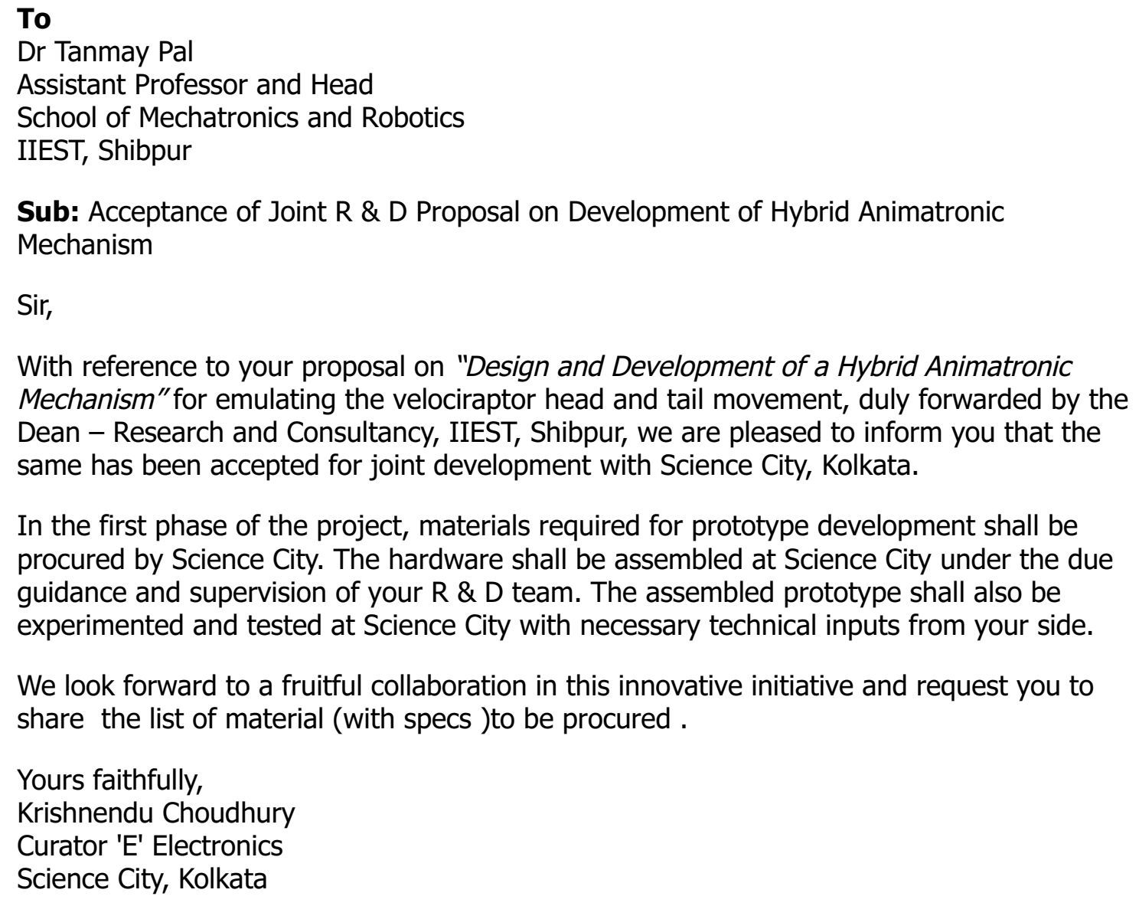  NITTTR, Bhopal, a Deemed to be University under the Ministry of Education, Government of India, is offering a diverse array of training programs for faculty and staff in the Technical and Higher Education Sectors for the year 2025-26.  The training calendar has been developed in line with the evolving educational landscape and Government of India initiatives like Vikshit Bharat and PM Gati Shakti. Programs cover both traditional areas and emerging fields:  Traditional Areas include Induction Training for newly recruited teachers, Advanced Pedagogy and Core Teaching Skills, and Department-Specific Training Programs.  Emerging Fields include AI, ML, IoT, Digital Twin, Drone Technology, AR, and VR, complemented by pedagogical principles.  Dr. Tanmay Pal attended the program ‘Robotics in Industry 4.0: Transforming Manufacturing’ from 16-20 June 2025.  Dr. Tanmay Pal, visited National Institute of Technology (NIT) Agartala, to attend the Two-day Pedagogy Workshop on Capacity Building on Design and Entrepreneurship (CBDE) hosted by the NIT Agartala.  The program schedule was as follows:  • Day-1 was to include an experience-sharing session by three faculty members from the 2024-25 cohort.  • Day-2 was to include a briefing on the progress of CBDE in the participating institutions by the PI or Co-PI from the host institute and 2-3 participating institutions.
Consultancy with Science City
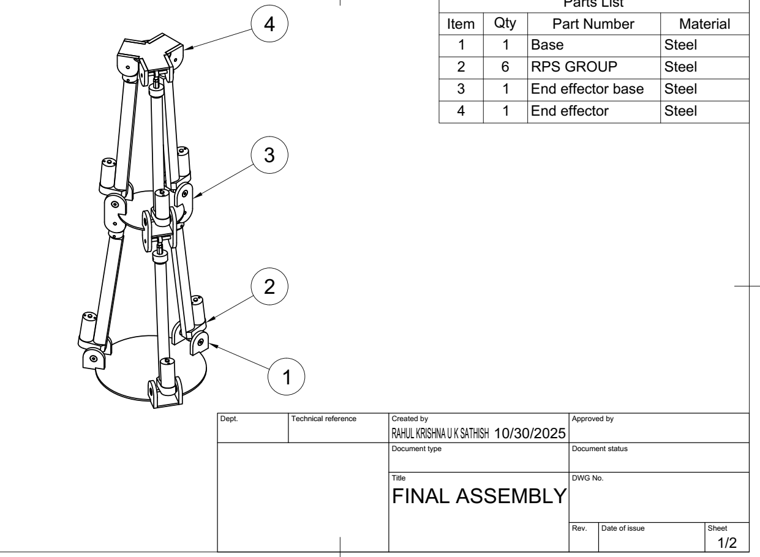

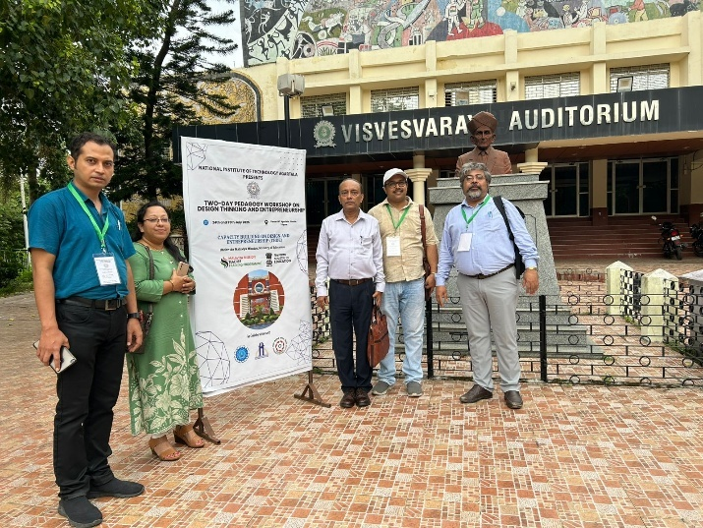
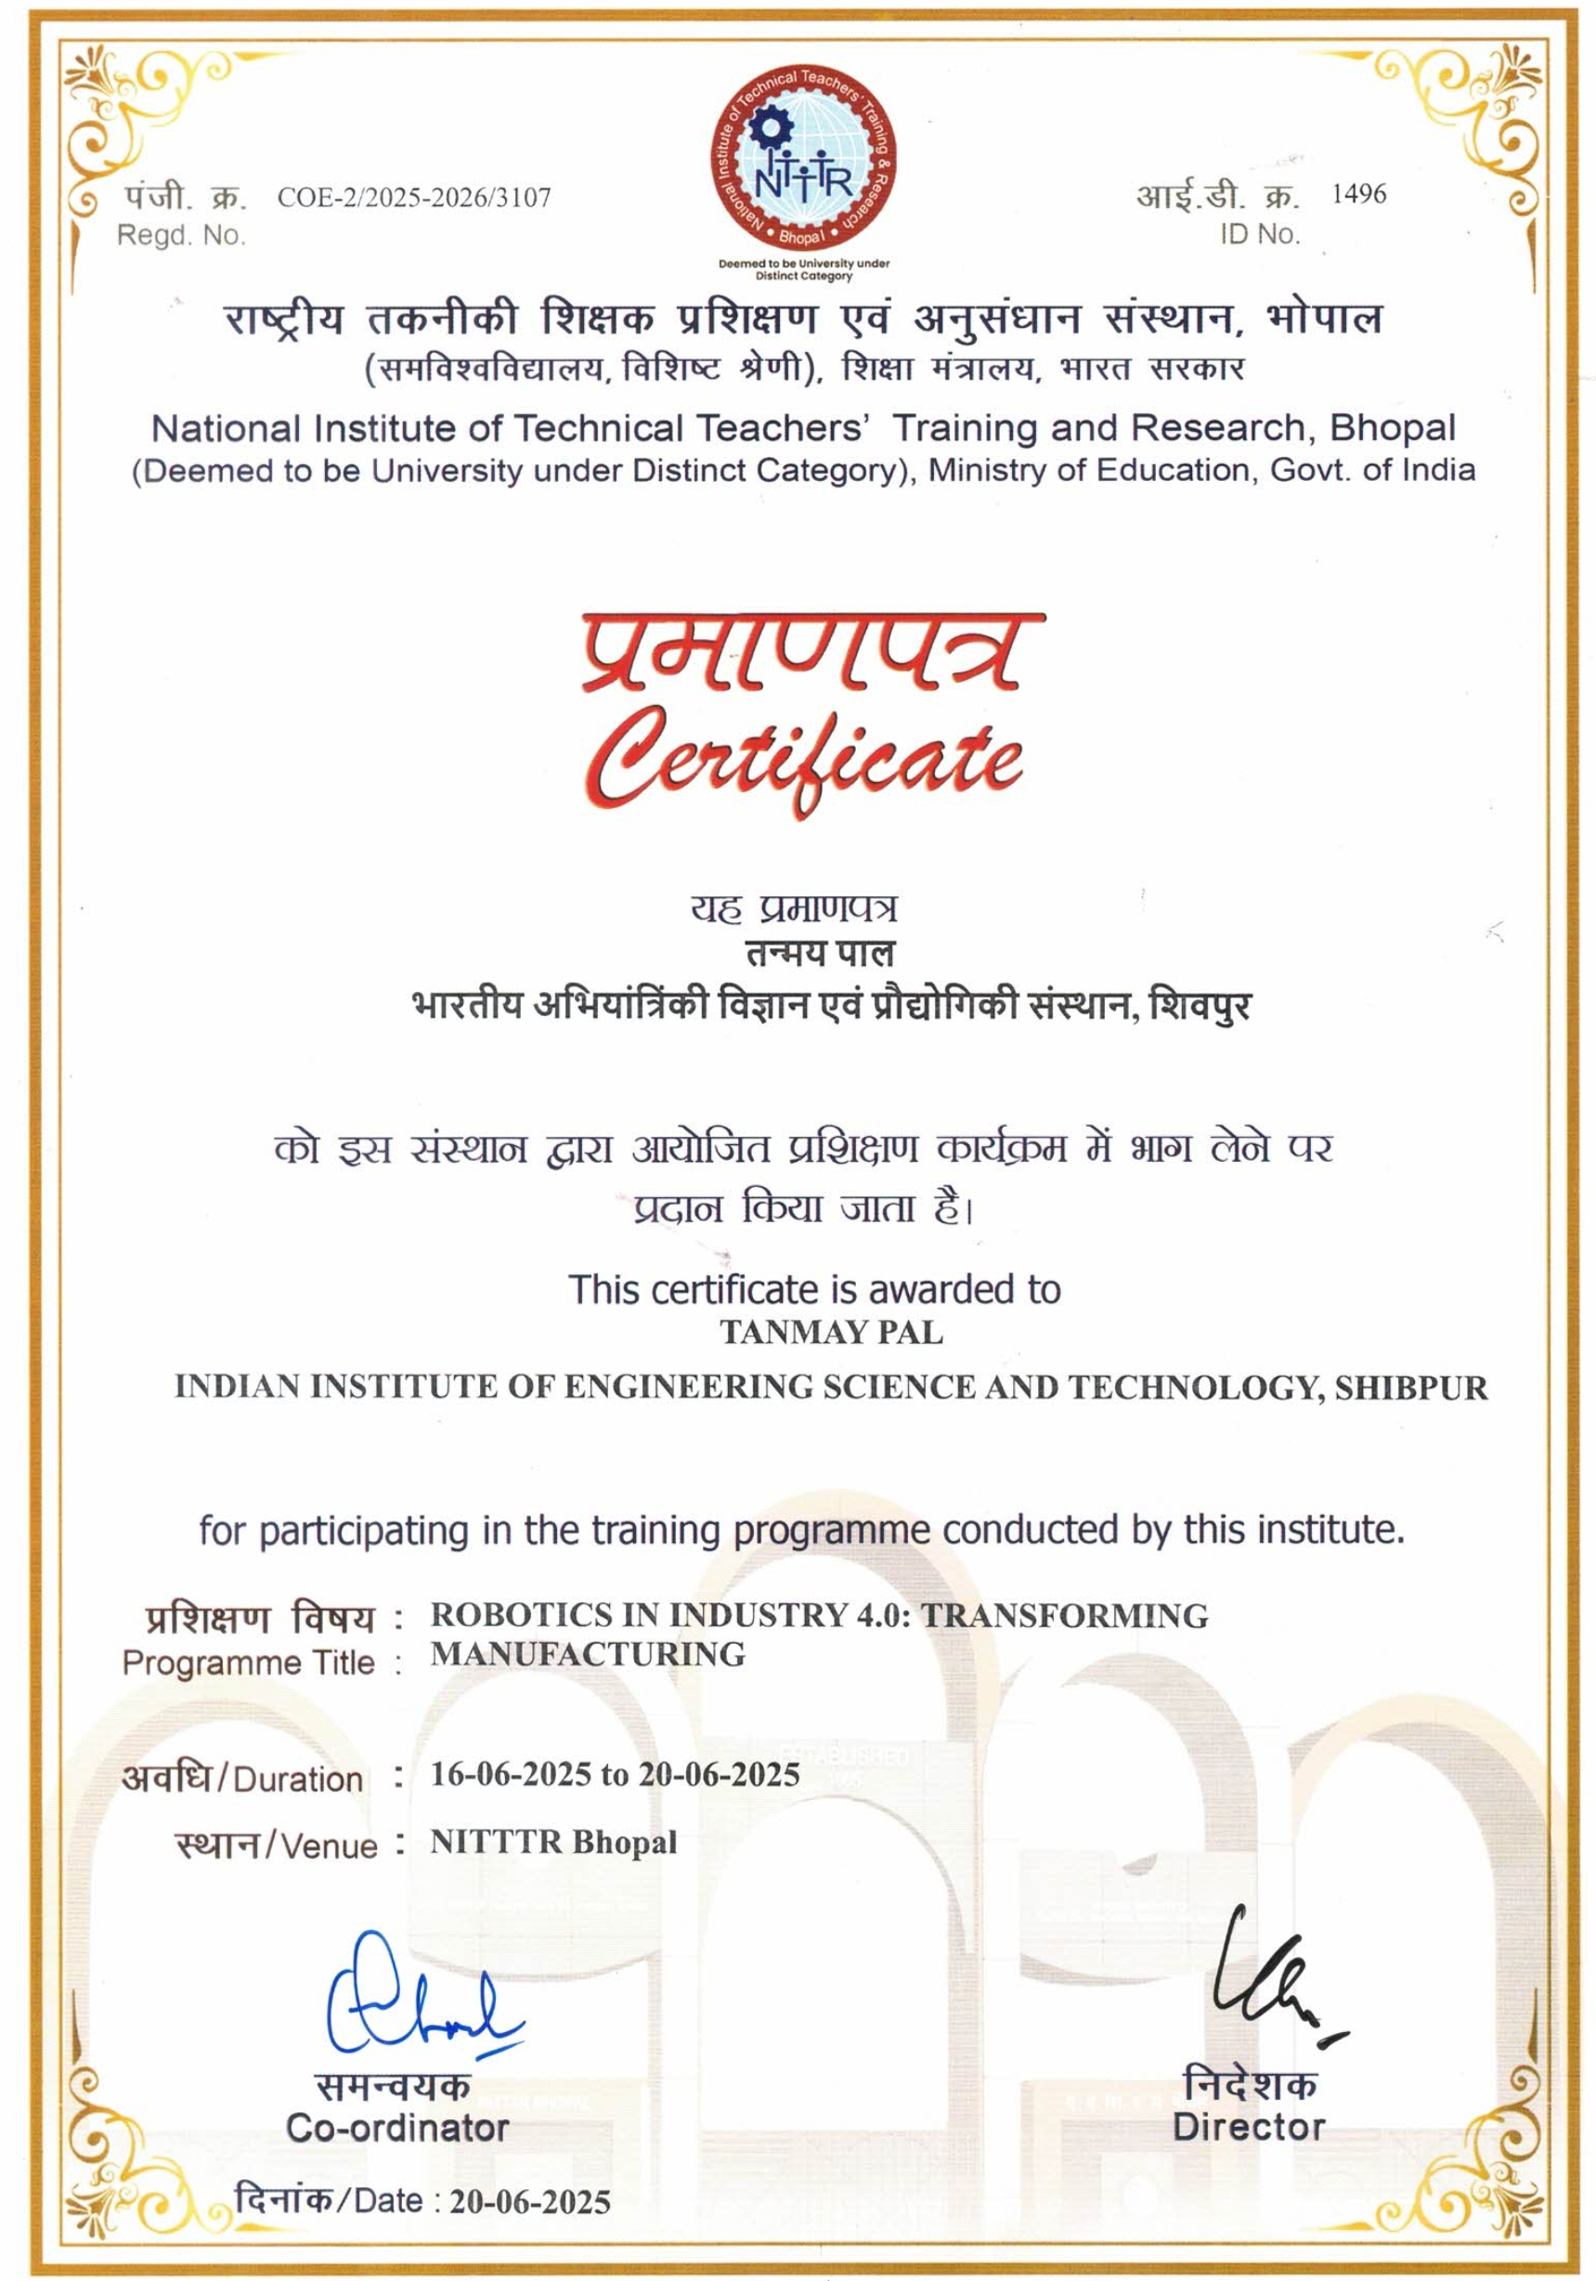
Publications
Journal

Anshuman Vikram and Tanmay Pal. A comparative analysis of computational models for respiratory frequency. Respiratory Physiology &Neurobiology, 337:104458, 2025
Conferences
Soham Banerjee, Dr. Anirudh Nath, Dr. Anirban Nag, Dr. Rajeeb Dey, Dr. Valentina E. Balas, Dr. Vlad Muresan. Design of Computed Torque Control with Regional Pole Placement for Two Link Robotic Manipulator. 29th International Conference on System Theory, Control and Computing, Cluj-Napoca, Romania, on October 9-11, 2025
Lab Development
The importance of IoT and Biomechatronics systems led to the acquisition of an healthcare system equipped with multiple sensors capable of measuring ECG, heartbeat, EMG and other such biomedical signals. The signals can be logged on real-time and stored in a cloud environment. The setup also creates the platform to implement AI algorithms on these obtained signals.
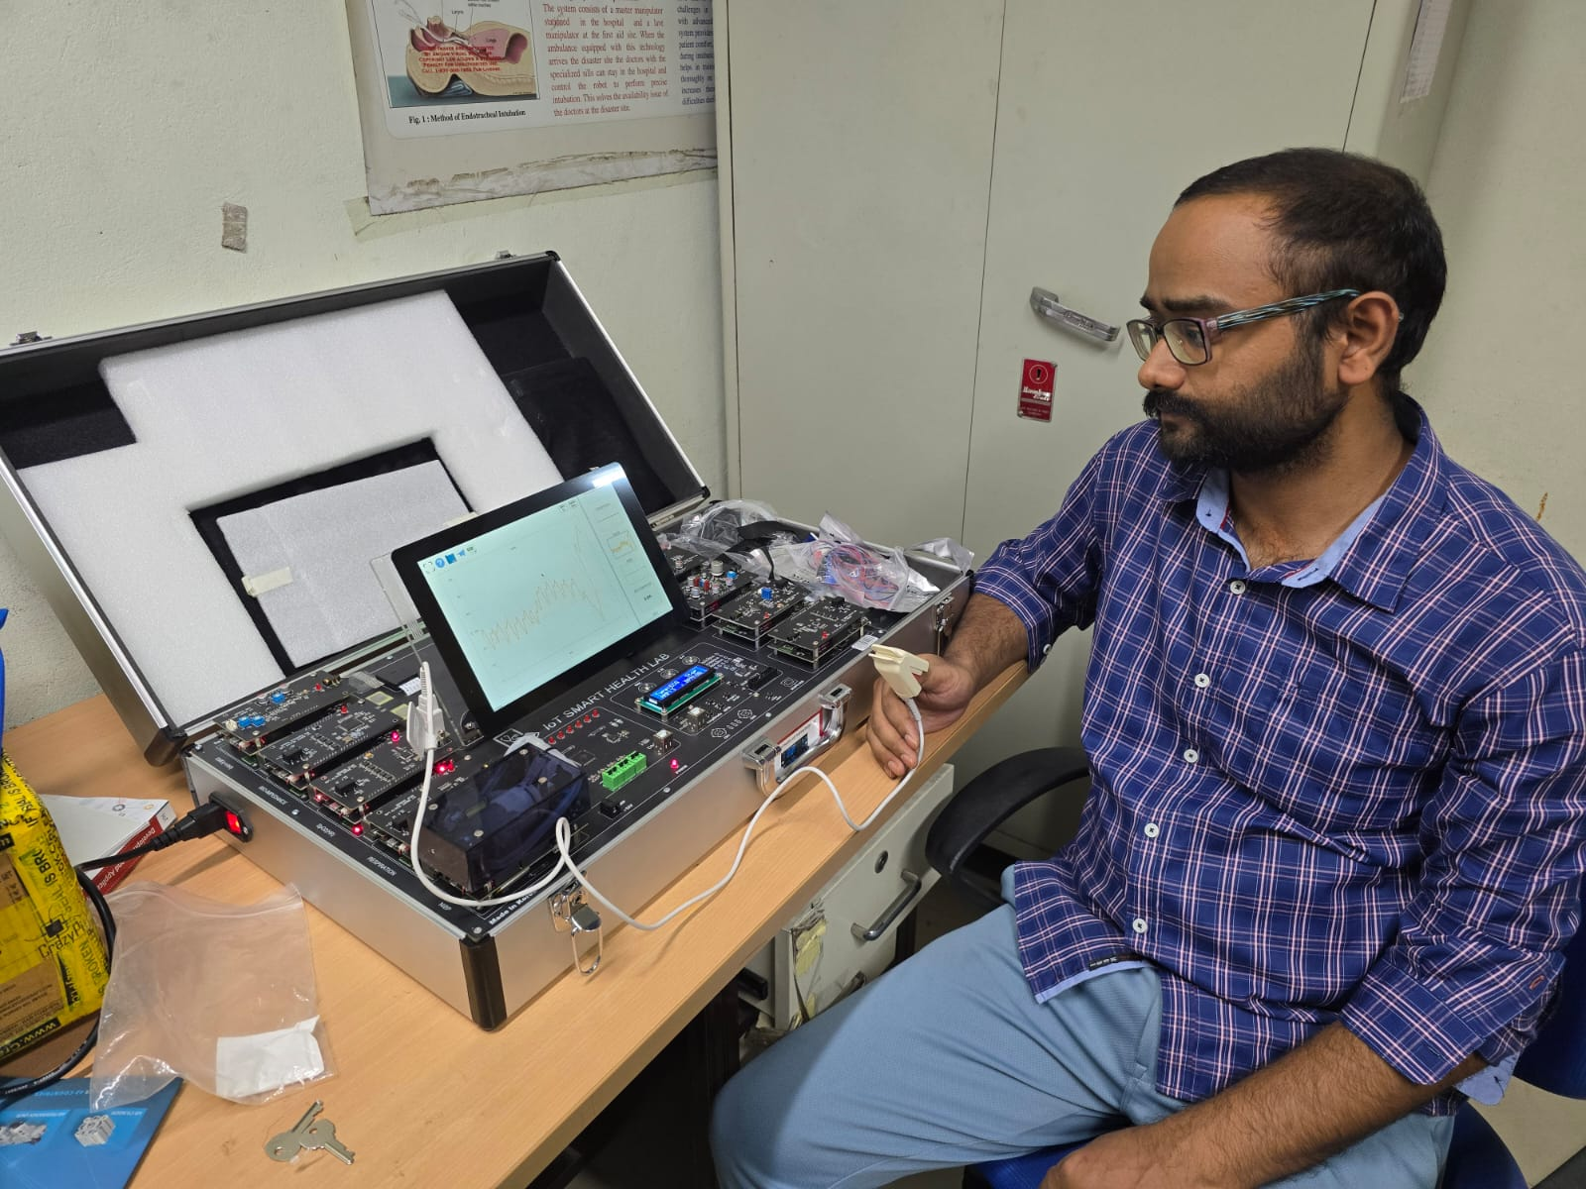

Invited talks
Dr. Anirban Nag delivered an invited talk titled “Embedded systems: The nervous system of a robot”, in the workshop Intelligent Embedded Controllers – The way forward IEC – 2025, organized by the Department of Electrical Engineering, Indian Institute of Engineering Science and Technology, Shibpur

